Exploring the Potential of Hybrid Deep Neural Networks

[[Everton Gomede, PhD](https://medium.com/@evertongomede?source=post_page-----8e013ea0bafe--------------------------------)](https://medium.com/@evertongomede?source=post_page-----8e013ea0bafe--------------------------------)

[[The Modern Scientist](https://medium.com/the-modern-scientist?source=post_page-----8e013ea0bafe--------------------------------)](https://medium.com/the-modern-scientist?source=post_page-----8e013ea0bafe--------------------------------)

[Everton Gomede, PhD](https://medium.com/@evertongomede?source=post_page-----8e013ea0bafe--------------------------------)

·

[Follow](https://medium.com/m/signin?actionUrl=https%3A%2F%2Fmedium.com%2F_%2Fsubscribe%2Fuser%2Fb1a64eb107f0&operation=register&redirect=https%3A%2F%2Fmedium.com%2Fthe-modern-scientist%2Fexploring-the-potential-of-hybrid-deep-neural-networks-8e013ea0bafe&user=Everton+Gomede%2C+PhD&userId=b1a64eb107f0&source=post_page-b1a64eb107f0----8e013ea0bafe---------------------post_header-----------)

Published in

[The Modern Scientist](https://medium.com/the-modern-scientist?source=post_page-----8e013ea0bafe--------------------------------)

·

6 min read

·

Jan 16

55

**Introduction**

The advent of deep learning has heralded a new era in the field of artificial intelligence, revolutionizing how machines interpret and learn from data. At the forefront of this revolution are Hybrid Deep Neural Networks (HDNNs), an innovative class of machine learning models that synergize different neural network architectures. This essay delves into the concept of HDNNs, their architecture, applications, advantages, and potential future developments.

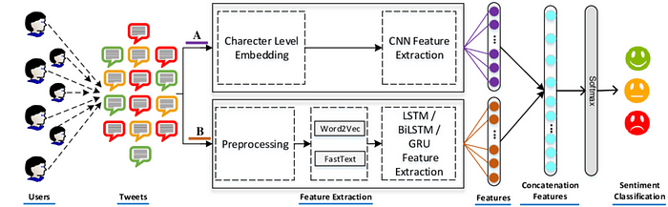

*In the symphony of artificial intelligence, Hybrid Deep Neural Networks are the maestros, orchestrating the harmonious blend of diverse neural architectures to create a masterpiece of learning and innovation.*

**Background**

A “Hybrid Deep Neural Network” typically refers to a neural network that combines different types of neural network architectures or methodologies to leverage the strengths of each. This can include a mixture of:

1. **Convolutional Neural Networks (CNNs)**: Ideal for processing grid-like data such as images, where they can efficiently handle spatial hierarchies.
2. **Recurrent Neural Networks (RNNs)**: Suited for sequential data like text or time series, as they can process inputs of varying lengths and maintain information across time steps.
3. **Feedforward Neural Networks**: These are basic neural networks with input, hidden, and output layers, useful for general-purpose learning.
4. **Autoencoders:** Used for unsupervised learning tasks, particularly in dimensionality reduction and feature learning.
5. **Generative Adversarial Networks (GANs):** Consisting of two networks, a generator and a discriminator, these are often used for generating new data samples that resemble the training data.

In a hybrid network, these components can be strategically combined. For example, a CNN might be used for feature extraction from images, which then feeds into an RNN for sequence processing in tasks like image captioning. Or, a feedforward network could be combined with an autoencoder for enhanced feature extraction and classification.

The goal of such hybrid systems is to capitalize on the strengths of each network type, often leading to better performance in complex tasks that require both spatial and sequential processing, or in tasks that benefit from both supervised and unsupervised learning methods.

**Concept and Architecture**

HDNNs are sophisticated models that merge various neural network architectures to harness their unique strengths. This fusion results in networks capable of processing diverse data types, handling complex patterns, and improving learning efficiency. Common architectures integrated into HDNNs include Convolutional Neural Networks (CNNs), known for their prowess in processing visual data; Recurrent Neural Networks (RNNs), effective in dealing with sequential data like text or time series; Feedforward Neural Networks, which are foundational to many deep learning tasks; Autoencoders, which excel in unsupervised learning for tasks like dimensionality reduction; and Generative Adversarial Networks (GANs), used primarily for generating realistic data samples.

By combining these architectures, HDNNs can perform tasks that are challenging for a single-model network. For instance, a CNN can extract features from an image, which are then processed by an RNN for applications like image captioning, thereby leveraging the spatial processing power of CNNs and the sequential data handling of RNNs.

**Applications**

The versatility of HDNNs allows their application across various domains. In healthcare, they assist in complex diagnoses by combining image recognition and patient history analysis. In autonomous vehicles, they integrate spatial recognition and sequential decision-making for safer navigation. HDNNs also play a crucial role in natural language processing, enhancing language translation, sentiment analysis, and chatbot responsiveness.

**Advantages**

The primary advantage of HDNNs lies in their ability to handle multiple data types and complex patterns, providing a comprehensive learning mechanism. This multiplicity leads to improved accuracy and efficiency in problem-solving. Additionally, they offer greater flexibility, allowing customization to specific tasks and requirements.

**Challenges and Future Directions**

Despite their advantages, HDNNs present challenges, notably in their complexity and computational requirements. Designing and training these networks requires significant expertise and resources. Furthermore, as with all AI systems, ethical considerations like privacy and bias need addressing.

The future of HDNNs lies in continued innovation. This includes exploring new combinations of architectures, enhancing efficiency, and developing models that are more interpretable and ethical. The integration of quantum computing with HDNNs could also open unprecedented possibilities in processing speed and complexity handling.

**Code**

Creating a complete Hybrid Deep Neural Network (HDNN) in Python along with a synthetic dataset and plots involves several steps. For this example, let’s design a simple HDNN that combines a Convolutional Neural Network (CNN) for feature extraction and a Feedforward Neural Network (FFNN) for classification. We will use a synthetic dataset for a binary classification task. The code will be structured as follows:

1. Imports: Necessary libraries and modules.
2. Synthetic Dataset Generation: Create a dataset suitable for our task.
3. HDNN Architecture Definition: Define the hybrid model.
4. Model Compilation and Training: Set up and train the model.
5. Evaluation and Plotting: Evaluate the model and plot the results.

Here’s a basic implementation:

import numpy as np  
import matplotlib.pyplot as plt  
from sklearn.datasets import make\_classification  
from sklearn.model\_selection import train\_test\_split  
from tensorflow.keras.models import Model  
from tensorflow.keras.layers import Conv2D, Flatten, Dense, Input, MaxPooling2D  
from tensorflow.keras.utils import to\_categorical  
  
# Generate a synthetic dataset  
X, y = make\_classification(n\_samples=1000, n\_features=6, n\_informative=3, n\_classes=2, random\_state=42)  
y = to\_categorical(y)  
  
# Reshape data to make it suitable for CNN (assuming 1D spatial data here)  
X = X.reshape(-1, 3, 2, 1) # Reshape to (3, 2) images  
  
# Split into train and test sets  
X\_train, X\_test, y\_train, y\_test = train\_test\_split(X, y, test\_size=0.2, random\_state=42)  
  
# Input layer  
input\_layer = Input(shape=(3, 2, 1))  
  
# CNN layers  
conv1 = Conv2D(32, kernel\_size=(2, 2), activation='relu')(input\_layer)  
pool1 = MaxPooling2D(pool\_size=(2, 2))(conv1)  
flat = Flatten()(pool1)  
  
# FFNN layers  
hidden1 = Dense(64, activation='relu')(flat)  
output\_layer = Dense(2, activation='softmax')(hidden1)  
  
# Create model  
model = Model(inputs=input\_layer, outputs=output\_layer)  
  
model.compile(optimizer='adam', loss='categorical\_crossentropy', metrics=['accuracy'])  
history = model.fit(X\_train, y\_train, epochs=10, validation\_split=0.2)  
  
# Evaluate the model  
loss, accuracy = model.evaluate(X\_test, y\_test)  
print(f"Test Accuracy: {accuracy \* 100:.2f}%")  
  
# Plotting training history  
plt.plot(history.history['accuracy'], label='Accuracy')  
plt.plot(history.history['val\_accuracy'], label='Validation Accuracy')  
plt.title('Model Accuracy')  
plt.ylabel('Accuracy')  
plt.xlabel('Epoch')  
plt.legend()  
plt.show()

Epoch 1/10  
20/20 [==============================] - 4s 55ms/step - loss: 0.5773 - accuracy: 0.7844 - val\_loss: 0.4438 - val\_accuracy: 0.9062  
Epoch 2/10  
20/20 [==============================] - 0s 16ms/step - loss: 0.3663 - accuracy: 0.9094 - val\_loss: 0.2937 - val\_accuracy: 0.9000  
Epoch 3/10  
20/20 [==============================] - 0s 14ms/step - loss: 0.2650 - accuracy: 0.9031 - val\_loss: 0.2337 - val\_accuracy: 0.9062  
Epoch 4/10  
20/20 [==============================] - 0s 13ms/step - loss: 0.2369 - accuracy: 0.9016 - val\_loss: 0.2275 - val\_accuracy: 0.9062  
Epoch 5/10  
20/20 [==============================] - 0s 15ms/step - loss: 0.2263 - accuracy: 0.9094 - val\_loss: 0.2130 - val\_accuracy: 0.9000  
Epoch 6/10  
20/20 [==============================] - 0s 18ms/step - loss: 0.2261 - accuracy: 0.9156 - val\_loss: 0.2325 - val\_accuracy: 0.9187  
Epoch 7/10  
20/20 [==============================] - 0s 21ms/step - loss: 0.2217 - accuracy: 0.9078 - val\_loss: 0.2081 - val\_accuracy: 0.8875  
Epoch 8/10  
20/20 [==============================] - 0s 20ms/step - loss: 0.2191 - accuracy: 0.9078 - val\_loss: 0.2185 - val\_accuracy: 0.9062  
Epoch 9/10  
20/20 [==============================] - 0s 14ms/step - loss: 0.2172 - accuracy: 0.9109 - val\_loss: 0.2127 - val\_accuracy: 0.9000  
Epoch 10/10  
20/20 [==============================] - 0s 14ms/step - loss: 0.2146 - accuracy: 0.9078 - val\_loss: 0.2105 - val\_accuracy: 0.9000  
7/7 [==============================] - 1s 6ms/step - loss: 0.2023 - accuracy: 0.9250  
Test Accuracy: 92.50%

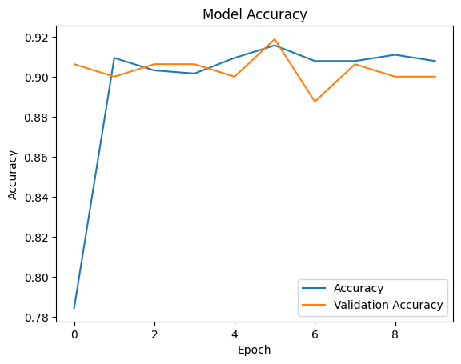

This code provides a basic framework. In practice, you would need to adjust the model architecture, hyperparameters, and dataset parameters according to the specific requirements of your task. Remember that working with HDNNs often involves a lot of experimentation and fine-tuning.

**Conclusion**

Hybrid Deep Neural Networks represent a significant stride in the journey of machine learning and artificial intelligence. By amalgamating various neural network architectures, they unlock new potential in data processing and problem-solving. While challenges exist, the ongoing advancements in this field promise to further elevate the capabilities of these sophisticated systems, paving the way for groundbreaking applications across diverse sectors.

[Hybrid-DNNs: Hybrid Deep Neural Networks for Mixed Inputs](https://arxiv.org/abs/2005.08419?source=post_page-----8e013ea0bafe--------------------------------" \t "_blank)

[Rapid development of big data and high-performance computing have encouraged explosive studies of deep learning in…](https://arxiv.org/abs/2005.08419?source=post_page-----8e013ea0bafe--------------------------------" \t "_blank)

[arxiv.org](https://arxiv.org/abs/2005.08419?source=post_page-----8e013ea0bafe--------------------------------" \t "_blank)

[Artificial Intelligence](https://medium.com/tag/artificial-intelligence?source=post_page-----8e013ea0bafe---------------artificial_intelligence-----------------)

[Machine Learning](https://medium.com/tag/machine-learning?source=post_page-----8e013ea0bafe---------------machine_learning-----------------)

[Deep Learning](https://medium.com/tag/deep-learning?source=post_page-----8e013ea0bafe---------------deep_learning-----------------)

[Neural Networks](https://medium.com/tag/neural-networks?source=post_page-----8e013ea0bafe---------------neural_networks-----------------)

[Recommendation System](https://medium.com/tag/recommendation-system?source=post_page-----8e013ea0bafe---------------recommendation_system-----------------)